**SE1748 – Đỗ Thế Phi – SE161229 – Lab 5 – BDI202**

**Exercise 1 :**

**Create Table Ex 1 :**

**Q1**

**Q2**

**Q3**

**Q4**

**Q5**

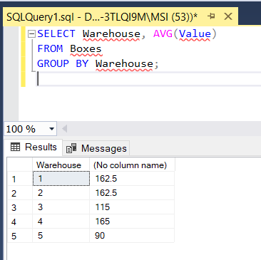

**Q6**

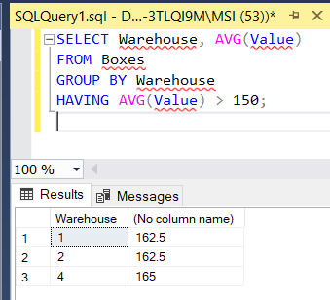

**Q7**

**Q8**

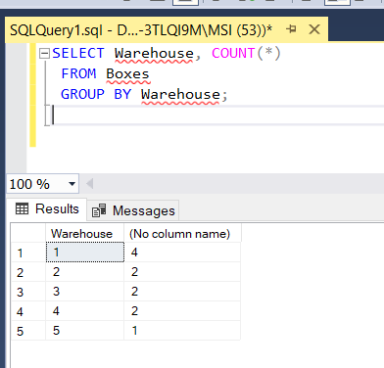

**Q9**

**Q10**

**Q11**

**Q12**

**Q13**

**Q14**

**Q15**

**Exercise 2 :**

**Create Table Ex 2 :**

**Q1**

**Q2**

**Q3**

**Q4**

**Q5**

**Q6**

**Q7**

**Q8**

**Q9**

**Q10**

